

Student Vacation! Two words together which sound like they mean fun, but in reality literally mean almost the exact opposite. However that is not to say that you can’t defy convention, get out and about and have a break from Bruce and all the study that you’ve (definitely) been doing. Here is the Billitin’s choicest selection of options from in and around Canberra.

*Doing it for Bill since 2014*

THE BRUCE BILLITIN

**ISSUE 15: Monday 30th May – Sunday 5th June**

*Doing it for Bill since 2014*



31st May

PUBLIC LECTURE: What the heck is going on in the U.S. presidential election?  
**31st May 6-7pm University House Hall**

The U.S. 2016 presidential election is one which has started out as one of the most raucous, populist, bombastic and downright crazy ones in the nation’s history. At this point it is difficult to predict the outcome in the November elections, but analysis of everything so far is nonetheless fascinating. Join Professor Carol Weissert as she discusses the election in the context of political science and electoral history, including the importance of party primaries, influence of campaign money, role of the press and more.

CANBERRA RAIDERS V MANLY SEA EAGLES  
**GIO stadium 3rd June Friday Night**

Friday night football is back in Canberra with a blast! With pyrotechnics and a special Raiders light display, as well as free beanies for the first 4000 people there, this is one match that would be a great way to let off some steam during exam period!

HAPPY BIRTHDAY PLAY SCHOOL: Celebrating 50 years   
**National Museum of Australia all day until 24th July**

Celebrating Australia’s longest running children’s television program, this exhibition has all the props and stories of your favourite childhood show on display. It’s been 50 years since it started, and I’m sure that many of you watched this when you were longer, so why not let the nostalgia train go choo choo, and go check out this truly playful exhibition. Tickets are only $6, and more info can be found at www.nma.gov.au

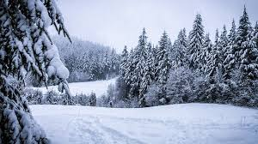

How it feels outside at the moment

*There is no more time-wasting process than that of believing people will act, and then finding that they will not –* Bill Mollison



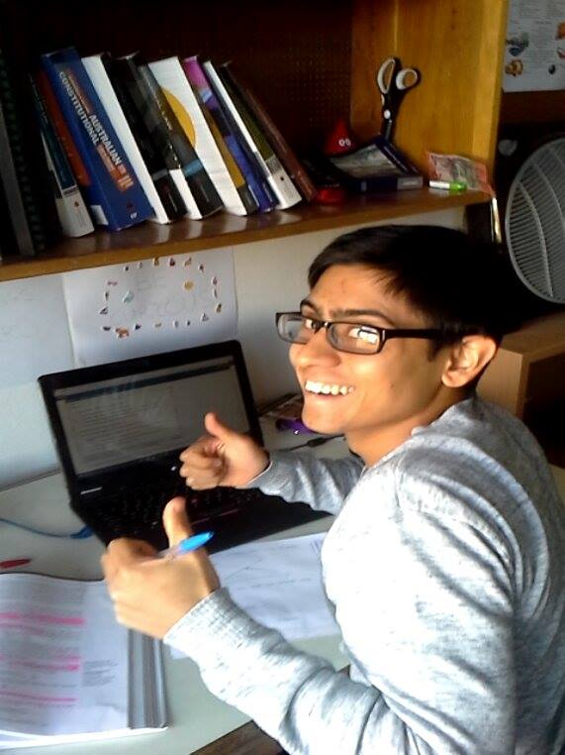

SOLICIT SAGAR: A  
guide to your Bruce Study   
Space Needs

Studying at Bruce can be hard,   
between the occasional midnight rave, the frequent requests of friends for   
stats help or even the need for some tasty banter memes, it can often be difficult to focus. Here are a few choice spaces around Bruce which I find help me with my study.

**Fishbowl** The eternal question of why is it   
 called the fishbowl will always   
 haunt this study space.  
 **Pros:** Occasional Cats, secluded  
 **Cons:** More flickering nights than

J.J. Abrams films.  
 **Rating:** meagre 7/10

**Computer Lab**

A place for all night sessions, wannabe librarians (ssssssh) and occasional printer (and subsequent student) meltdowns.  
**Pros:** Great internet for ‘study’  
**Cons:** People can see what you are ‘studying’  
**Rating:** Good 7/10

**Packard Library**Better than a history channel documentary at making people in it look knowledgeable.   
**Pros:** You can brag to your friends about sightings of a rare Packardian  
**Cons:** Distance to get there, everyone else actually looks like they are studying hard.  
**Rating:** Solid 7/10

**Dining Hall**

A neverending supply of hot chocolate and fresh fruit awaits you in this veritable study paradise  
**Pros:** Occasional wink from Stavros, endless amounts of foooood  
**Cons:** Having to hide under the tables in cleaning time.  
**Rating:** Super Solid 7/10

EXAM PREP TUTORIALS

Our awesome Tutor and pastoral care team are putting on some tutorials to help you be better prepared in the lead up to your exams.

Monday 30th of May

|  |  |
| --- | --- |
| 6-7PM | ECON1101 – Microeconomics 1 |
| 7-8PM | LAWS1203 – Torts |
| 8-9PM | PHIL1004 – Intro to Philosophy |

Tuesday 31st of May

|  |  |
| --- | --- |
| 6-7PM | MATH1013 – Maths and Applications 1 |
| 7-8PM | CHEM1101 – Chemistry 1 |
| 8-9PM | PHYS1101 – Physics 1 |

Wednesday 1st of June

|  |  |
| --- | --- |
| 6-7PM | STAT1008 – Quantitative Research Methods |
| 7-8PM | LAWS1201 – Foundations of Australian Law |
| 8-9PM | LAWS1205 – Criminal Law & Procedure |

Thursday 2nd of June

|  |  |
| --- | --- |
| 6-7PM | POLS1005 – Introduction to IR |
| 7-8PM | POLS1002 – Intro to Politics |

Wednesday 8th of June

|  |  |
| --- | --- |
| 7-8PM | LAWS1205 - Australian Public Law |



TRIVIA

1. Who directed the 2003 film ‘The Room’, considered to be one 6. How many US supreme court justices are there?  
of the worst films ever made? 7. Who wrote the book “The Little Mermaid’?

2. What song is the tune of Liechtenstein’s national anthem from? 8. Which actor was the voice of Darth Vader in the original

3. What language is the word karaoke originally from? Star Wars films?

4. In science, how long is an eon? 9. Which late 19th century painter was famours for having

5. Which canberra suburb takes its name from an aboriginal word chopped off his ear?  
meaning star? 10. What animal has the longest gestation period?



**Top tip:**Put sticky notes up for inspiration

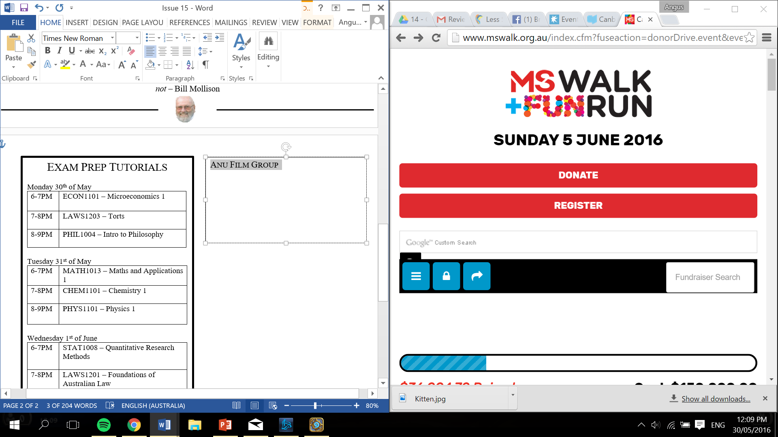

1. Tommy Wiseau, 2. God Save the Queen, 3. Japanese, 4. A billion years, 5. Giralang, 6. 9, 7. Hans Christian Andersen, 8. James Earl Jones, 9. Vincent Van Gogh, 10. The African Elephant